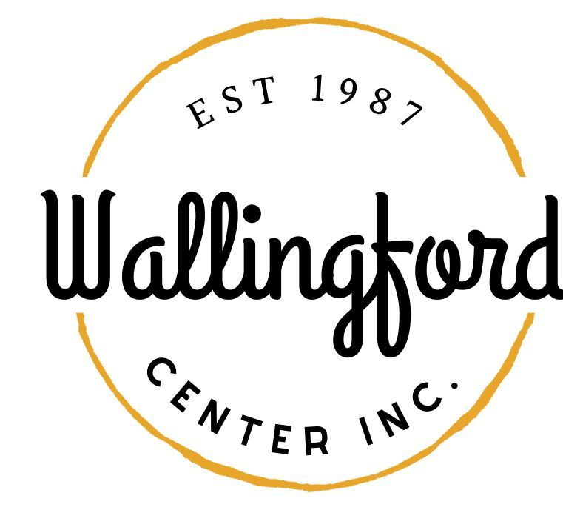
Regular Meeting/Annual Meeting
Tuesday, Dec. 5 2023
Wallingford Hubcap
128 Center Street Wallingford, Ct 06492
5:30 pm in person

- Call to Order
  - Appointment of Temporary Secretary
  - Appointment of Alternates
- Approval of minutes
  - Regular Meeting Nov. 8, 2023
- Public Comments-Comments are asked to be limited to 2 minutes
- Guest Nick Lombardi and Peter Ford (Center St. Brewery)
- Treasurer Report- November 2023
- New Business
a) Report on Holiday Stroll
b) Report from Stephanie
c) Idea to contract out Steph for SM post to merchants
c) Volunteer appreciation -Annette Pyskaty re: Celebrate & Holiday
Stroll
d) Update on YMCA Road Race
e) CW leaders -see handout
f) Budget Committee- set up Jan. meeting -need Bd members to sign up
Marge, Liz, -would like 2 more people
g) set up a meeting with the new mayor
h) Jan. guest – EDC reps- Joe Mirra and Don Crouch-updates
VII. Communications
- Executive Director Report-written Nov. 2023 -will be submitted late due to Stroll
VIII. Report from committees
- Hubcap -no board meeting in Nov.
- Wallingford Arts Council- no meeting in Nov.
- Community Resource -no meeting in Nov.
- Executive Session pursuant to CGS 1-200 6a ; the purpose of the session is a discussion of the review of staff
- Adjournment

