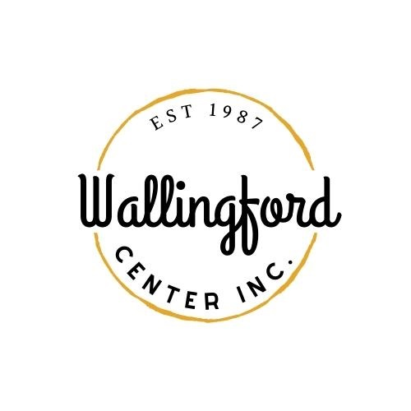
Regular Meeting
Tuesday, Feb. 6, 2024
Wallingford Center
128 Center Street Wallingford, CT 06492
5:30 pm in-person
I. Call to Order
- Appointment of Temporary Secretary
- Appointment of Alternates
- Appoint Interim Secretary- Mike Brunjes
II. Approval of minutes
Regular Meeting Jan. 9, 2024
III. Public Comments-Comments are asked to be limited to 2 minutes
IV. Guest Introductions: Jason Michael, Kristen Gilbride, and Andrea Serna
V. Treasurer Report- Feb.2024
VI. Review the proposed 2024-2025 budget
VII. New Business
- Update on businesses downtown
- Landlord committee and potential meeting
- Online merchandise sale
- Rohm grant for Trash Bins through DEEP
- Stephanie's report
- Proposal of New Event from Mike Brunjes
VIII. Old Business
a) Report from Board Chair / ED on Meeting with Mayor
b) Merchandise at local businesses
c) Update on WCI cell phone

VII. Communications
a) Executive Director Report-written and provided via email
VII. Report from committees
- Hubcap -discuss new requirements for board members
- Wallingford Arts Council- update on upcoming events
- Community Resource - No Update
- Report on Celebrate Wallingford - review pricing for vendors/merchandise sales
IX. Executive Session pursuant to CGS 1-200 6a; the purpose of the session is a discussion of staff items
X. Adjournment

