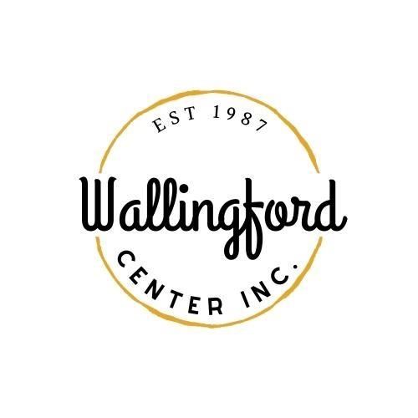
Regular Meeting
Tuesday, April 2, 2024
Wallingford Center
128 Center Street Wallingford, CT 06492
5:30 pm in-person
- Call to Order
  - Appointment of Temporary Secretary
  - Appointment of Alternates
- Approval of minutes - Regular Meeting March 5, 2024
- Public Comments-Comments are asked to be limited to 2 minutes
- Guest Introductions: Kristen & Amanda Gilbride (Green Kettle) and Andrea Serna (resident)
- Standing Reports
  - Treasurer Report- March 5th 2024
  - Executive Directors Report-written provided by email
  - Stephanie -Social Media Report, online store, review of event ticket, current website updates
  - Report on Celebrate Wallingford from committee-Road Race needs to meet with the Police and Civic organizations regarding increased fees.
  - Rest HOP/Art Show-Ticket locations/Wallingford Magazine, and Artist participants and postcards
- Old Business
  - Electrical proposal needs to bid on the project
  - Puzzle- Linda Adamo
  - Landlord Meetings -need a Board member to organize it
  - Porch Fest- Mike Brunjes
- New Business
  - Nick Lombardi-Strategic Plan meeting-potential date
B. Jason Michael -Movie events
C. Annual Meeting -have it at a different venue/agenda/invite some guest
D. Dumpster- April 13th or 14th-Choate Football team can help -vote needed
E. Cement Barriers-Simpson Court- need to discuss our options -need a vote
F. Wallingford Plan of Conservation & Development (POCD)
- Adjournment

