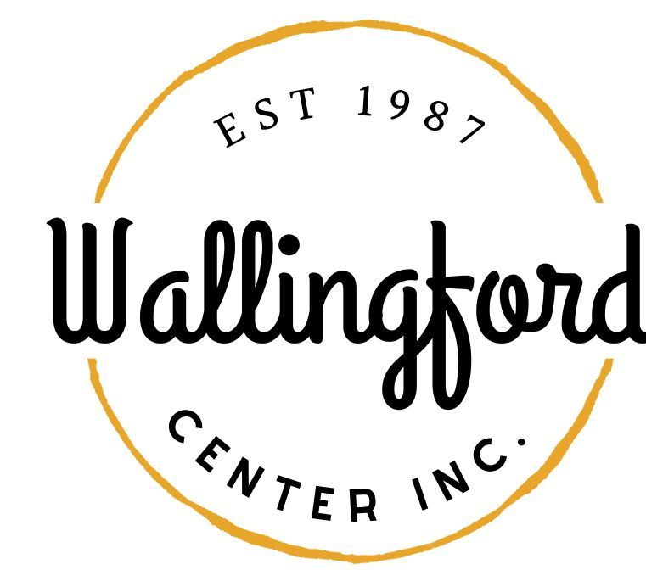
Regular Meeting/Annual Meeting
Weds, Nov. 8, 2023
Wallingford Hubcap
128 Center Street Wallingford, Ct 06492
5:30 pm in person

- Call to Order
  - Appointment of Temporary Secretary
  - Appointment of Alternates
- Approval of minutes
  - Regular Meeting Oct. 10, 2023
- Public Comments-Comments are asked to be limited to 2 minutes
- Guest Nick Lombardi, Carl Rosa (CT Main St.)
- Treasurer Report- October 2023
- New Business
- Carl will review CT Main ST survey
b. Report back on Celebrate-evals summary
c. Discussion on Holiday Stroll-update
d. Assistant for Office
e. Bench for Simpson Court
- Separate phone cell phone for office
- YMCA -Road Race on Saturday, Oct 5th, 2024
VII. Communications
- Executive Director Report-written Sept/Oct 2023
VIII. Report from committees
- Hubcap
- Wallingford Arts Council
- Community Resource
- Executive Session pursuant to CGS 1-200 6a ; the purpose of the session is a discussion of the review of staff
- Adjournment

