BUILD A BRICK ORDER FORM
WALLINGFORD CENTER'S INC.'S BRICK FUNDRAISER OFFERS A UNIQUE WAY TO SUPPORT & SHOW YOUR SUPPORT TO OUR TOWN. SET "YOUR NAME IN STONE!" BRICKS ARE PLACED ON NORTH MAIN STREET, SOUTH MAIN STREET & CENTER STREET.
Mail this completed form with a check to:
Wallingford Center, Inc, 128 Center Street, Wallingford, CT 06492.
Visit our office located in the HUBCAP storefront at 128 Center Street.
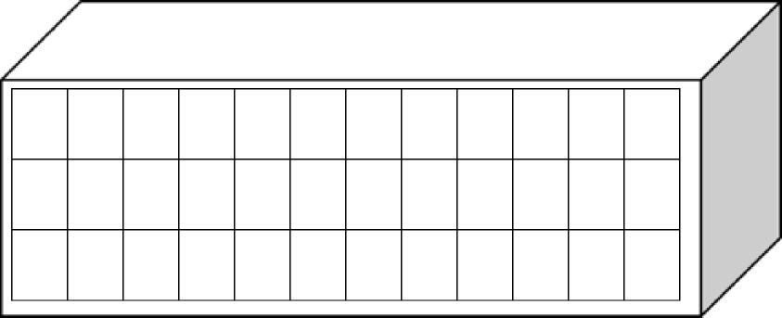
Please fill in one capital letter (or number) per block. Punctuation and spaces are to be counted.
12 Spaces per line up to 3 lines per brick
$65 per brick: Cash Check # ______
We accept credit cards at this time.
Purchaser’s name and address
Date: Cell: email
Where would you like the brick(s) to be placed?

(You can be very specific as to location. Blank bricks are pulled, and the inscribed bricks are inserted)
We will notify you when the brick is placed. We install bricks 2 times per year (Fall & Spring)
PHONE: 203-284-1807 EMAIL: WCI@WALLINGFORDCENTERINC.COM WALLINGFORD CENTER INC. 128 CENTER STREET, WALLINGFORD CT
Rev 2.17.23

