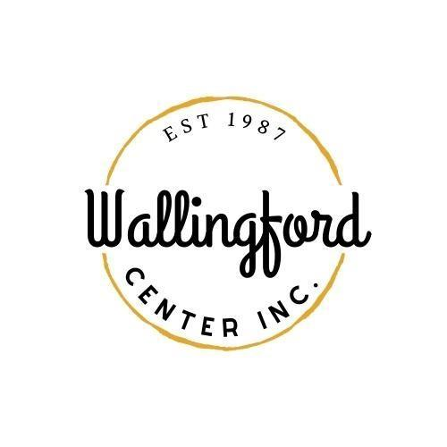
Regular Meeting
Tuesday, Feb. 6, 2024
Wallingford Center
128 Center Street Wallingford, CT 06492
5:30 pm in-person
Attended by:
Staff Members Liz Davis and Stephanie Garcia
Board members Marge Abbagnaro, Linda Adamo, Mike Brunjes, Leah Masella, Nathaniel Bottone, Peter Ford, Nick Lombardi, Nikki Trocchio, Jeff Knickerbocker

Absent: Alison Cady, Bruce Conroy

Call to Order at 5:36pm Nikki Trocchio presiding over meeting

Jeff Knickerbocker entered meeting and takes over as moderator at 5:48

Motion by Linda Adamo to appoint Interim Secretary Mike Brunjes Second by Nick Lombardi passed by unanimous vote

Motion by Leah Masella to approve minutes of WCI regular meeting on January 9th 2024 as amended Second Nick Lombardi by passed unanimous vote

Guest Introductions: Jason Michael, and Andrea Serna

Motion to receive and approve treasurer's report made by Leah Masella Seconded Marge Abbagnaro passed by unanimous vote

Motion to authorize Liz Davis to replace remaining wreaths and bows up to $31,000 made by Marge Abbagnaro and Second Nikki Trocchio passed by unanimous vote

Review the proposed 2024-2025 budget

Highlighted changes from last year's budget to this years
Motion to approve budget for presentation to mayor made by Leah Masella Second Nick Lombardi passed by unanimous vote

Liz Davis gave updates on openings and closing of business in downtown area and prospects for vacant storefronts

Pete Ford and Nick Lombardi will help gather lower center street landlords to help formulate a plan and strategy for business in the area.

Stephanie will report on the possibilities of selling WCI merch online next meeting

Liz Davis working on pricing for more trash bins for center of town through Rohm

Stephanie's report - See attached

Mike Brunjes Raised the idea of Wallingford hosting Porchfest and will forward more information to the board

Report from Board Chair / ED on Meeting with Mayor
Mayor clarified questions about how line items on budgets are clarified

Liz Davis motioned to establish cell phone service for her for WCI Business made by Mike Brunjes Second Leah passed by unanimous vote

Liz Davis gave update on date for Restaurant Hop and date is set for May 15th.

Liz Davis informed Hubcap is requiring a fundraising requirement of $1000 to be part of their board. Liz will follow up with Hubcap and the protocols that they set for board members.

Wallingford Arts Council- update on upcoming events Art show at WCI featuring Wallingford schools week of May 13th as part of the HOP.

Report on Celebrate Wallingford - review pricing for vendors/merchandise sales
Motion by Linda Adamo to revise prices for booths at Celebrate Wallingford as follows: Food Vendors $600, Businesses $300, Civic Orgs $100, Crafts $200. Second by Peter Ford passed by unanimous vote
Motion to adjourn at 7:17pm by Mike Brunjes Second Pete Ford passed by unanimous vote.

