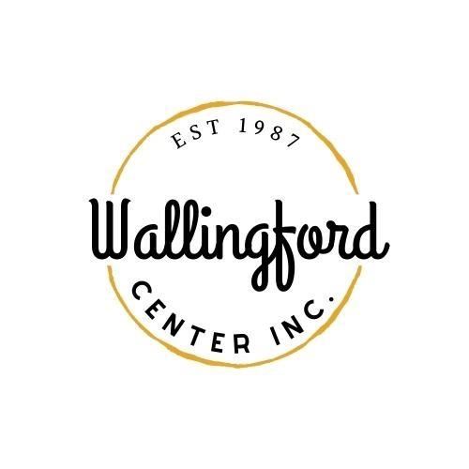
Regular Meeting
Tuesday, March 5, 2024
Wallingford Center
128 Center Street Wallingford, CT 06492
5:30 pm in-person
- Call to Order
  - Appointment of Temporary Secretary
  - Appointment of Alternates
- Approval of minutes - Regular Meeting February 6th, 2024
- Public Comments-Comments are asked to be limited to 2 minutes
- Guest Introductions: Jason Michael (merchant), Kara Morrison (allnex), Kristen & Amanda Gilbride (Green Kettle), and Andrea Serna (resident)
- Standing Reports
  - Treasurer Report- Feb. 6th 2024
  - Executive Directors Report-written provided by email
- review new businesses coming into our area
- Live Nation Sponsorship
  - Stephanie -Social Media Report, online store, review of event ticket comparison, current website updates
  - Report on Celebrate Wallingford from committee-Road Race, apps, Food Truck fees
- Old Business
  - Electrical proposal for permanent electricity uptown
  - Landlord meeting-scheduling for March 7th
  - Update on HOP/Art Show & Wing Fest
  - Discussion on Porch Fest
- New Business
  - Nick Lombardi-Strategic Plan meeting-potential date
  - Landscaper Proposal -watering, planting and weeding

C. Movie events -Jason Michael
D. Website proposal
E. Map update-interactive and hard copy
- Executive session pursuant to CGS 1-200 6a; the purpose of the session is to discuss Jason Michael’s application as a board member.
- Adjournment

