Wallingford Restaurant HOP
Wallingford Artist Walk
Wednesday, May 15, 2024
Event time: 5-9 PM
Set up time: 4 PM
Local Artisan’s Application
Name:________________________________________
Address:_______________________________________
Best contact #:__________________________________
Do you prefer inside or outside_____________________
Describe your artwork:________________________________
____________________________________________________________

Submit pictures via email by April 30th. They should be appropriate for public display. You are responsible for displaying pictures on an easel or table or hung if available. The location of your display will be provided before the event.

_______________________________________________________
Signature Date
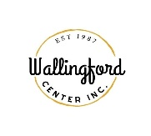
Return your completed application to:
Wallingford Center Inc. 128 Center St., Wallingford, CT 06492
wci@wallingfordcenterinc.com
(203) 284-1807

WCI is not responsible for any damaged items, equipment, or personal belongings. Vendors are solely responsible for protecting and safeguarding their property and releasing WCI or any other parties from any losses or damage to their property.

