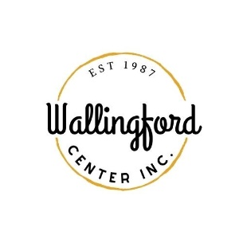
New Car Show
Application
Celebrate Wallingford 2024
October 5th & 6th
Saturday 11-6 pm and Sunday 11-5 pm (rain or shine)
Deadline: Sept 15, 2024
Name of Dealership………………………………………………………….
Application fee: $500.00 (for both days and each car dealer is required to supply a certificate of insurance )
We will be exhibiting the following cars…………………………………………………
…………………………………………………………….
The number of cars being displayed………………(up to 6 cars per dealership)

to participate in this event.
Name of person responsible for booth………………………………….……
Cell phone number……………………………………………………………
Dealership number……………………………………………………………
Email address…………………………………………………………………….
Do you wish to bring your cars the night before?..................(parking lot on Center Street behind TD Bank)
Signature……………………………………………………………….
Contact: Wallingford Center Inc.
128 Center St., Wallingford, CT 06492
wci@wallingfordcenterinc.com
(203) 284-1807

